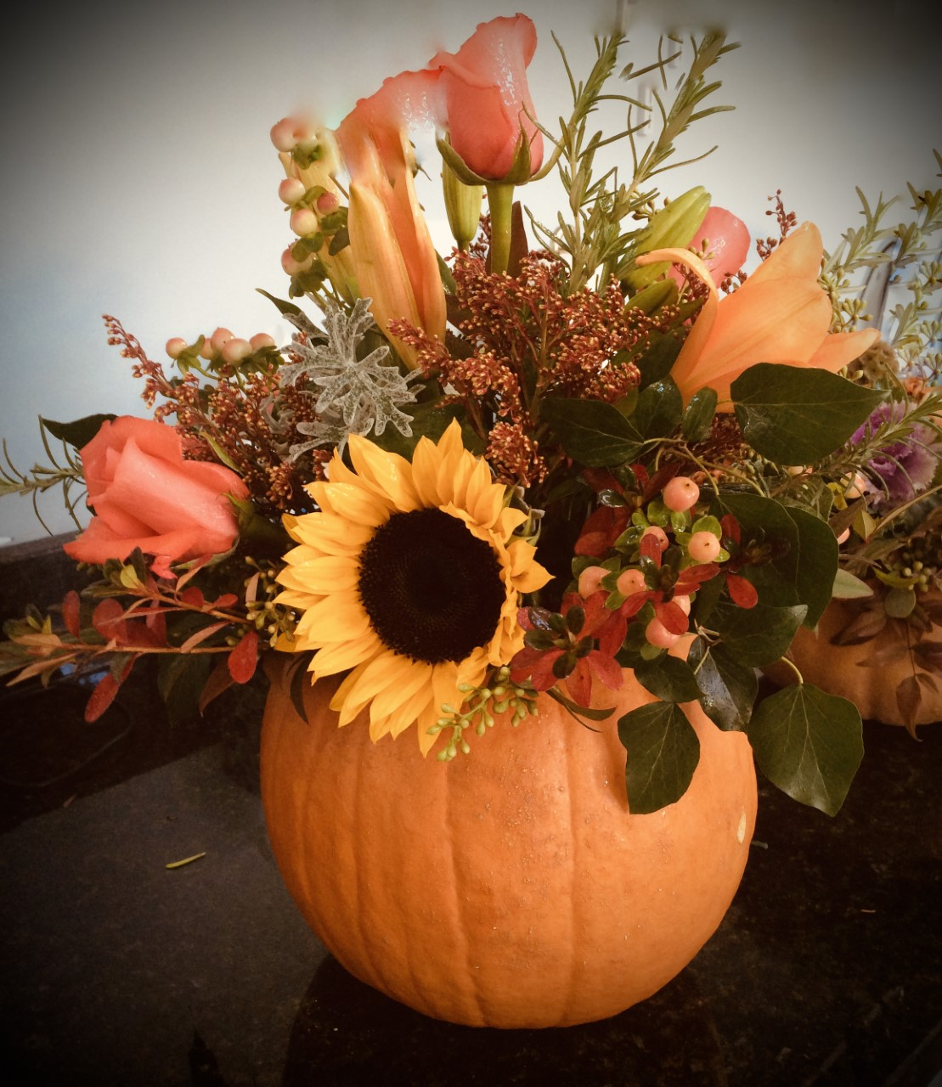
If you are having a fall gathering and want a WOW centerpiece, this pumpkin sale is for you! The 60 plus creations include traditional and heirloom pumpkins designed with fall flowers and foliage, and sometimes crowned with the cutest little succulents ever! There are other containers, if real pumpkins aren’t your thing. This is first come-first served and the event is cash and carry (local checks accepted). Help make our garden club’s annual fundraiser a success!
Rock Spring Garden Club’s
Floral Pumpkin Sale

All proceeds support our community outreach programs.

November 22, 2021

4:00pm-7:00pm

The Home of Mary Lunger

4629 N 32nd Road

ARLINGTON, VA 22207

