May the Road Rise Up to Meet You
An NGC Small Standard Flower Show
Presented by: Rock Spring Garden Club. Members of
District III, National Capital Area Garden Clubs, Inc. Central Atlantic Region
of State Garden Clubs, Inc., Piedmont District, Virginia Federation of Garden Clubs, Inc., South Atlantic Region of National Garden Clubs, Inc.
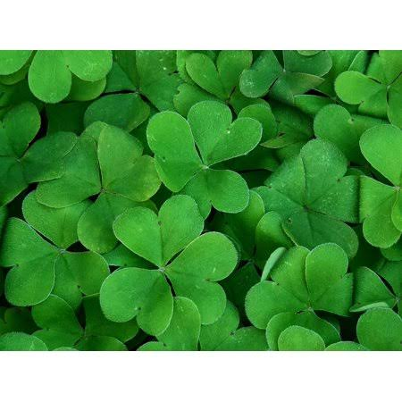
Working Schedule
Staging: 3/16/22 1:00pm Horticulture and Design Entries: 3/16/22 2:00-3:30pm; 3/17/22 8:00-9:00am Judging: 10:00-11:30am. Open by Invitation 12:15-1:00pm
Site: Little Falls Presbyterian Church, 6025 Little Falls Rd., Arlington VA 22207
When: March 17, 2022

